Prepared by CGMS-TFMI

Agenda Item: WG

Discussed in WG

CGMS-WMO Task Force on Metadata Implementation

WIS Portal Usability Report

# INTRODUCTION

The WIS infrastructure has been declared operational in 2012 and it has reached a stage where satellite data providers can use the WIS as a distribution platform for making available their products. In order to further increase the satellite data providers’ involvement and allow the distribution of more satellite data products through the WIS, it was decided to create a CGMS-WMO Task Force on Metadata Implementation (TF-MI) to ease the creation of satellite metadata describing products for the WIS discovery catalogues. An additional objective of the CGMS-WMO TF-MI was also used to review and is also to relay comments/inputs from the satellite data user’s community regarding the usage of the WIS infrastructure, especially for accessing satellite products. This document presents in a consolidated way, the satellite data users’ community inputs regarding the WIS Portals and includes suggestions and considerations from the TF-MI specialists for improving the accessibility of the WIS.

# WIS Portal USABILITY

The WIS is a great opportunity for Satellite data providers to easily distribute and access satellite data products by using agreed protocols and standards. A user can already from any GISCs’ portals discover and access satellite data products. A current shortcoming is however that there are still a number of satellite data users which prefer to use the different individual satellite data providers’ infrastructures instead of the WIS. Users from the satellite data community have expressed concerns regarding the usability of the WIS portals and the difficulty to find satellite products. Within this report CGMS TF-MI has organised, verified and rationalised users’ feedback in order to channel that message to the WMO expert team in charge of the WIS implementation (ET-WISC).

The main difficulties encountered by the users are summarised below and could be applied in general not only to the WIS portals but also to Earth science data portals.

* Discovery experience not focused towards access on products,
* Complexity and usability of the discovery interface
* Difficulties to return only relevant search results
* Miss a way to introduce and present available products for novice users
* Heterogeneity of WIS portal interfaces leading to users confusion

Those issues are described in the subsequent chapters with a set of recommendations from the satellite product users community in order to improve and increase the WIS Portal usage.

## Focus on products

One of the undertakings of the WIS is to bring meteorological data to a much broader user community. This can be achieved by providing an easier and simpler access to meteorological data by using standard web technologies. WIS portals are now allowing anybody to discover meteorological data but in general the WIS portals are not sufficiently focusing on the main users’ need the ‘product’. Satellite data users coming to these portals want to easily discover and access products, understand what those offered products are and access them to download and work with them. Users have expressed that when using the different WIS Portals, it is often quite difficult to get directly access to information related to the products such as for instance product descriptions or how to access the product and under which terms & conditions. The search results are often populated with technical product identifiers and the users have to tediously scan through the list and click on each product to get the product description.

The designed web interfaces are also often not targeted on potential new users but often on specialists accustomed to the existing WMO usages. For instance, users often need to understand the GTS conventions to grasp which EO products are available from the WIS Portals.

Below is a set of examples to illustrate and highlight those difficulties. Below a simple example searched for ‘wind’ products.

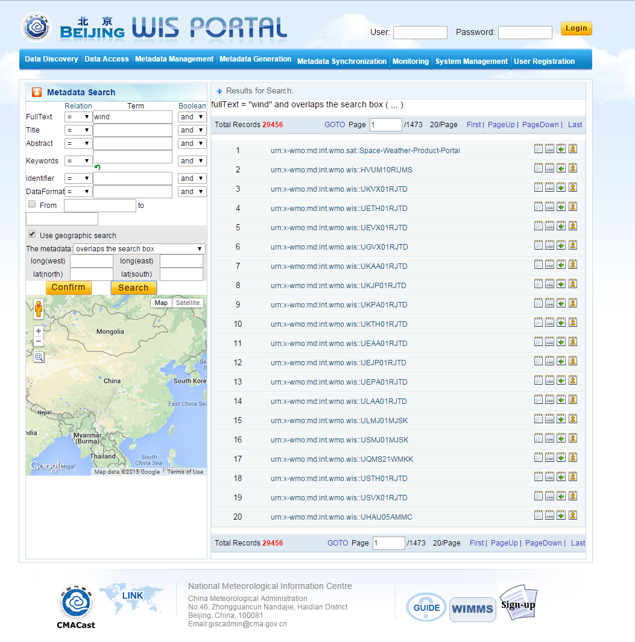

For instance in the GISC Beijing Portal, with the returned results, it is impossible for a non-GTS specialist to judge if the results of the search are really wind products.

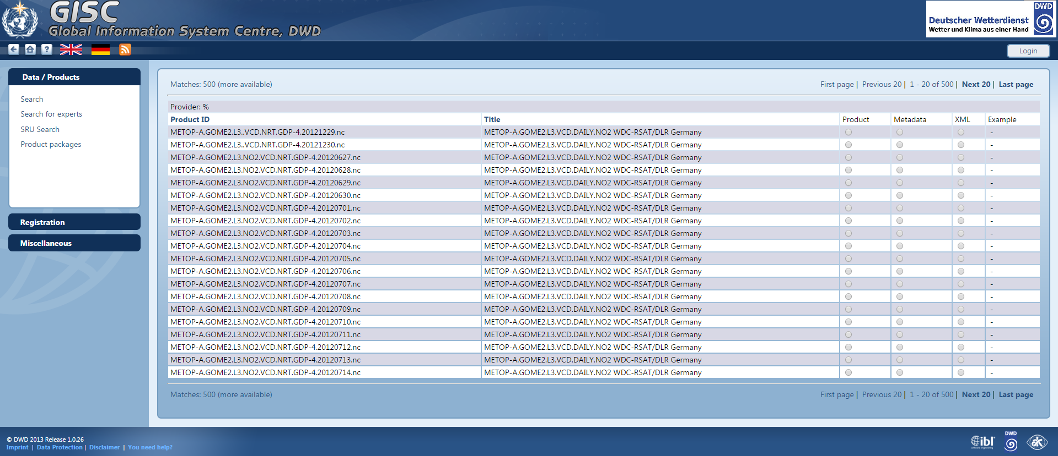

The Title of the products is presented in the result page of GISC Offenbach but it is not always sufficient to discover what products are available through the catalogue because the metadata content is not sufficiently informative. The results presentation here also forces the user to click on each individual product to get more details on the products. In addition, the search executed in the above example is also no longer reflected on the entire page and the user looses the relation between search and results. This can quickly become annoying and will push the user to leave the portal.

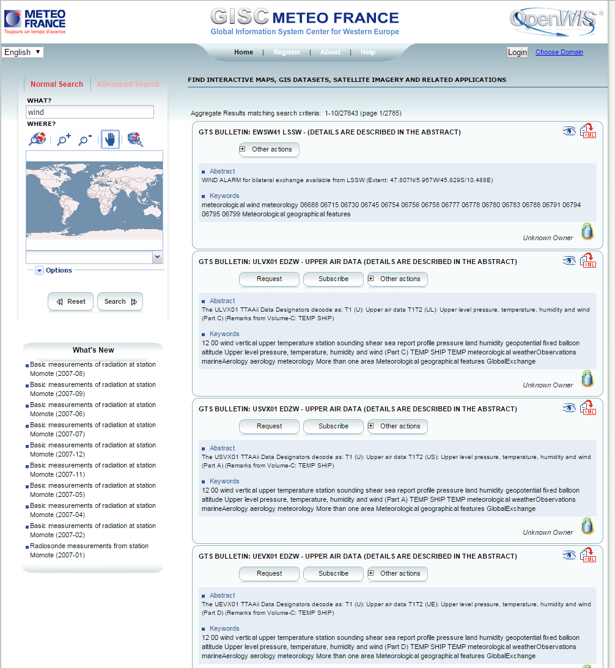

The abstract is here immediately displayed on the search result page of GISC Toulouse but the Abstract information is not always relevant, as it has been produced using a template with the GTS bulletin headers format.

***In the first phase of the WIS creation, the WIS Portal providers have been focusing on successfully establishing the WIS technical platform. Now, to increase the WIS adoption, the satellite data users’ community is recommending WIS Portal providers to consider centring the portals’ user interface on product discovery and presentation to ensure that non-WMO specialists can understand the information discoverable on the WIS.***

## Complexity of the discovery interface

Satellite data users when searching on the WIS portals have also reported that user interfaces are not always following the de-facto standards established by the global players of search web sites. Users of the WIS portals are also web users making a daily use of web standards or web search engines like Google, Bing or Amazon. Those web sites have established conventions with regards to look and feel, usability and navigation. Users expect to have the same conventions adopted when using other portals such as in the WIS. To start a free text search it is generally expected to use a predominant text box as input. The search result pages still show the search terms and for the results each hit with a short title for the EO product and a short description with meaningful information regarding the EO products. Users also expect to refine the already entered keywords to filter further the results. Alternatively like on Amazon, the search result page can contain associated keywords for filter the search (type of products, price range, ...).

|  |  |
| --- | --- |
| bing.png  Entry page centered focusing on search text box | google.png  Search result page with title and descriptions |

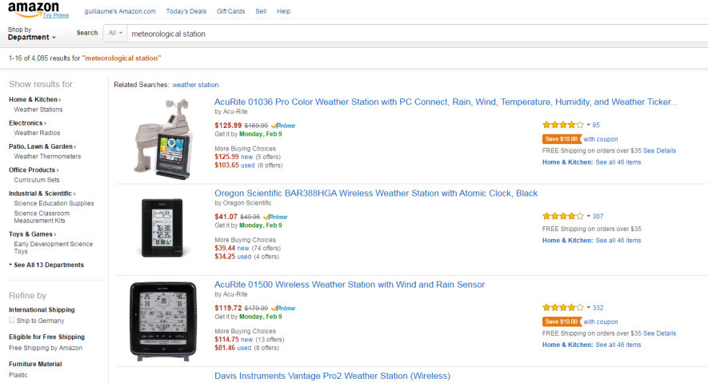

Search page with filtering on the left side

Most of those domain-based search portals however implement a different search experience that tends to make the search experience more complex.

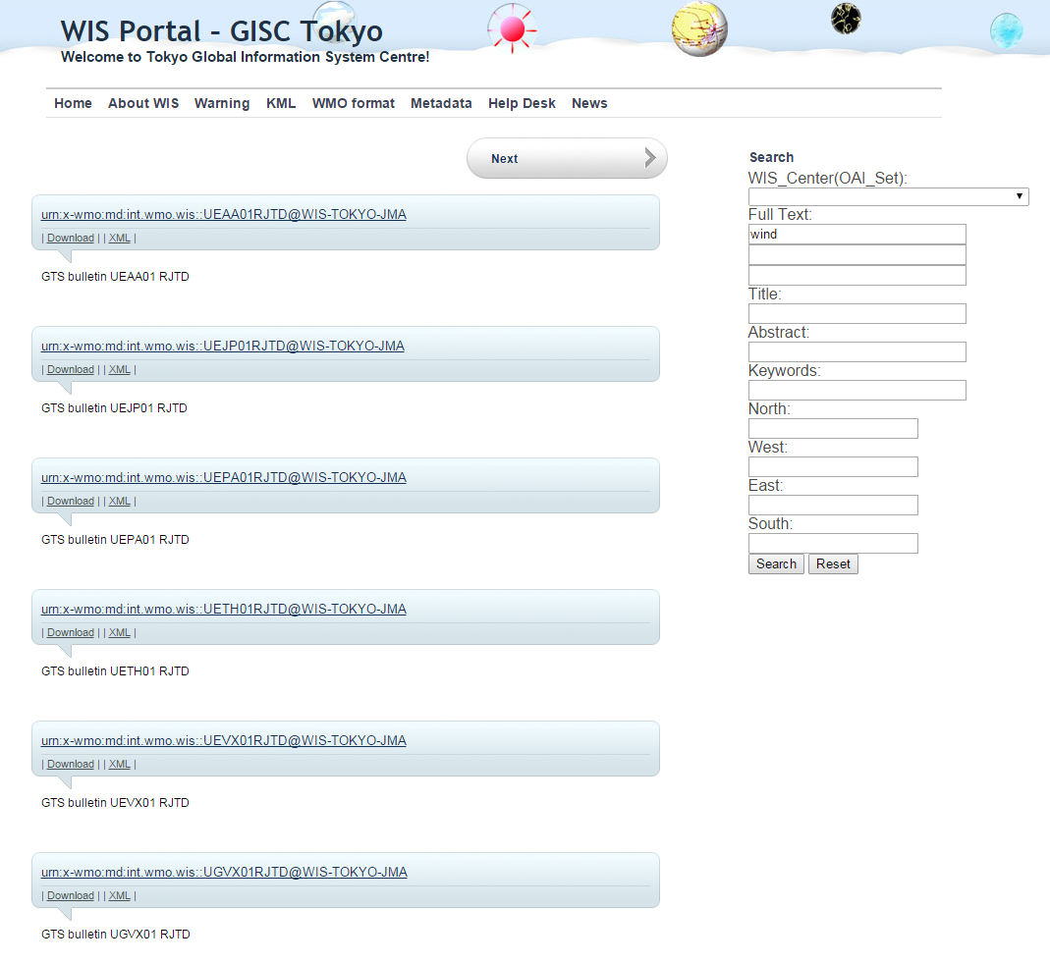

GISC Tokyo Portal search is on the right side and offers different search text boxes for Title, Abstract and Keywords.

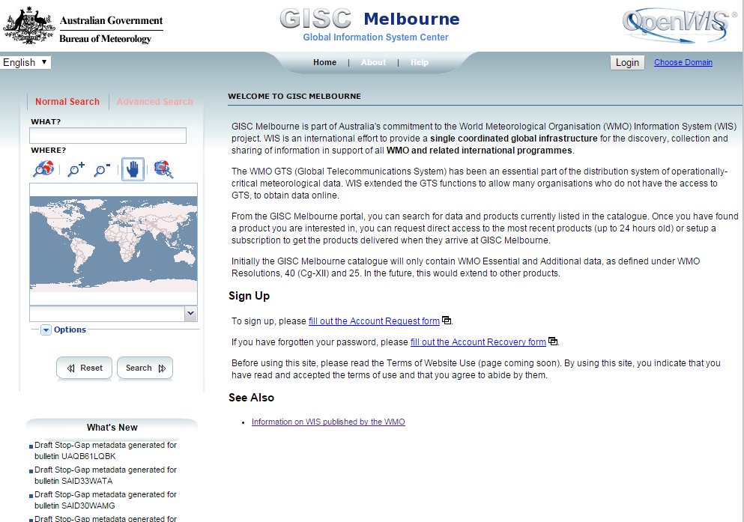

The search of OpenWIS Portals like for instance GISC Melbourne is available on the left side with multiple options that make the search less user-friendly.

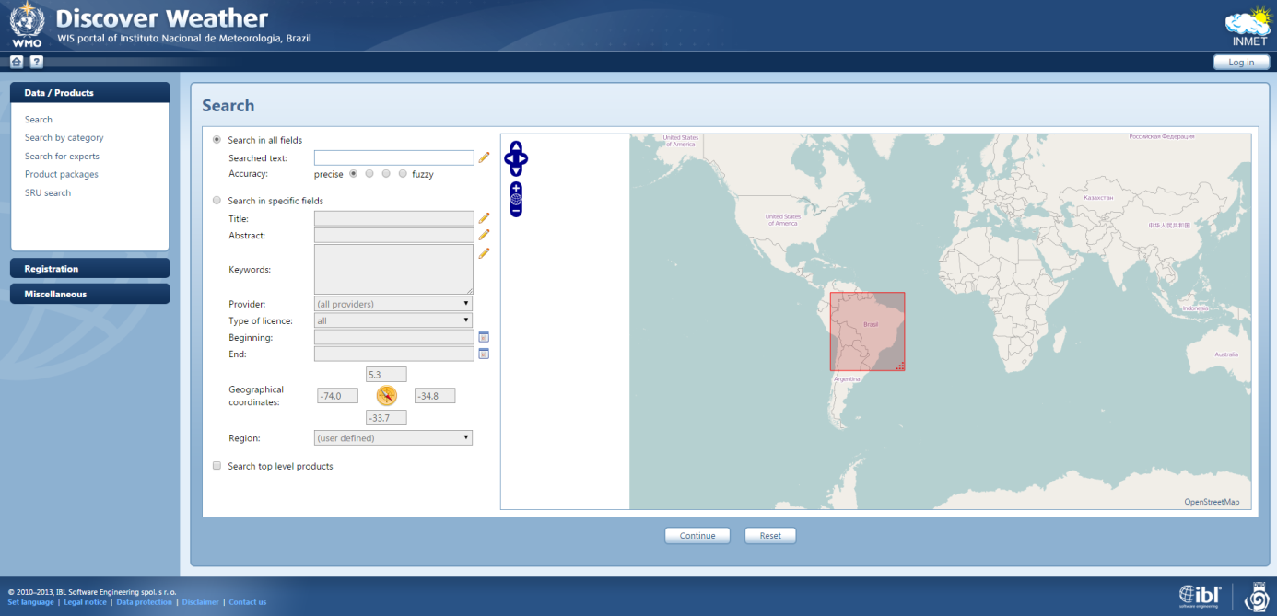

The GISC Brasilia search page is offering a set of complex options, which can be difficult to understand for a user. The accuracy of the search is also a feature that cannot be understood by the user (difference between precise and fuzzy).

***The satellite data user community recommends to take into consideration the simplification of the search user interfaces by implementing the conventions that have been used in commercial search engines in order to take advantages of the automatisms developed by users over the years and make them feel at “home” when looking for meteorological products on the WIS.***

## Non-relevant search results

Satellite data users have reported difficulties to find relevant products from the WIS portals. The search results returned could be completely unrelated to the search keywords or populated by results of individuals’ products that make them non-practical. One reason for that issue is due to the fact that each GTS individual bulletin reference is described as a product collection, which makes those products dominating the search indexes and therefore polluting the search results with non-relevant results.

Additionally, lots of metadata records do not contain enough pertinent information regarding the products to provide relevant and meaningful results to the users.

An effort needs to be done when metadata records are created to ensure that the necessary information is entered to provide relevant results to the users. This is one of objective of the CGMS TFMI, which is going to create the necessary documentation to help satellite data providers create and curate metadata records.

Finally users would also expect to see how the search keywords match with the returned results. This is usually done on standard search engines by highlighting in the result descriptions the discovered keywords. Currently no WIS Portals are providing such feature and this would greatly help users understanding the relation between their searches and the returned results.

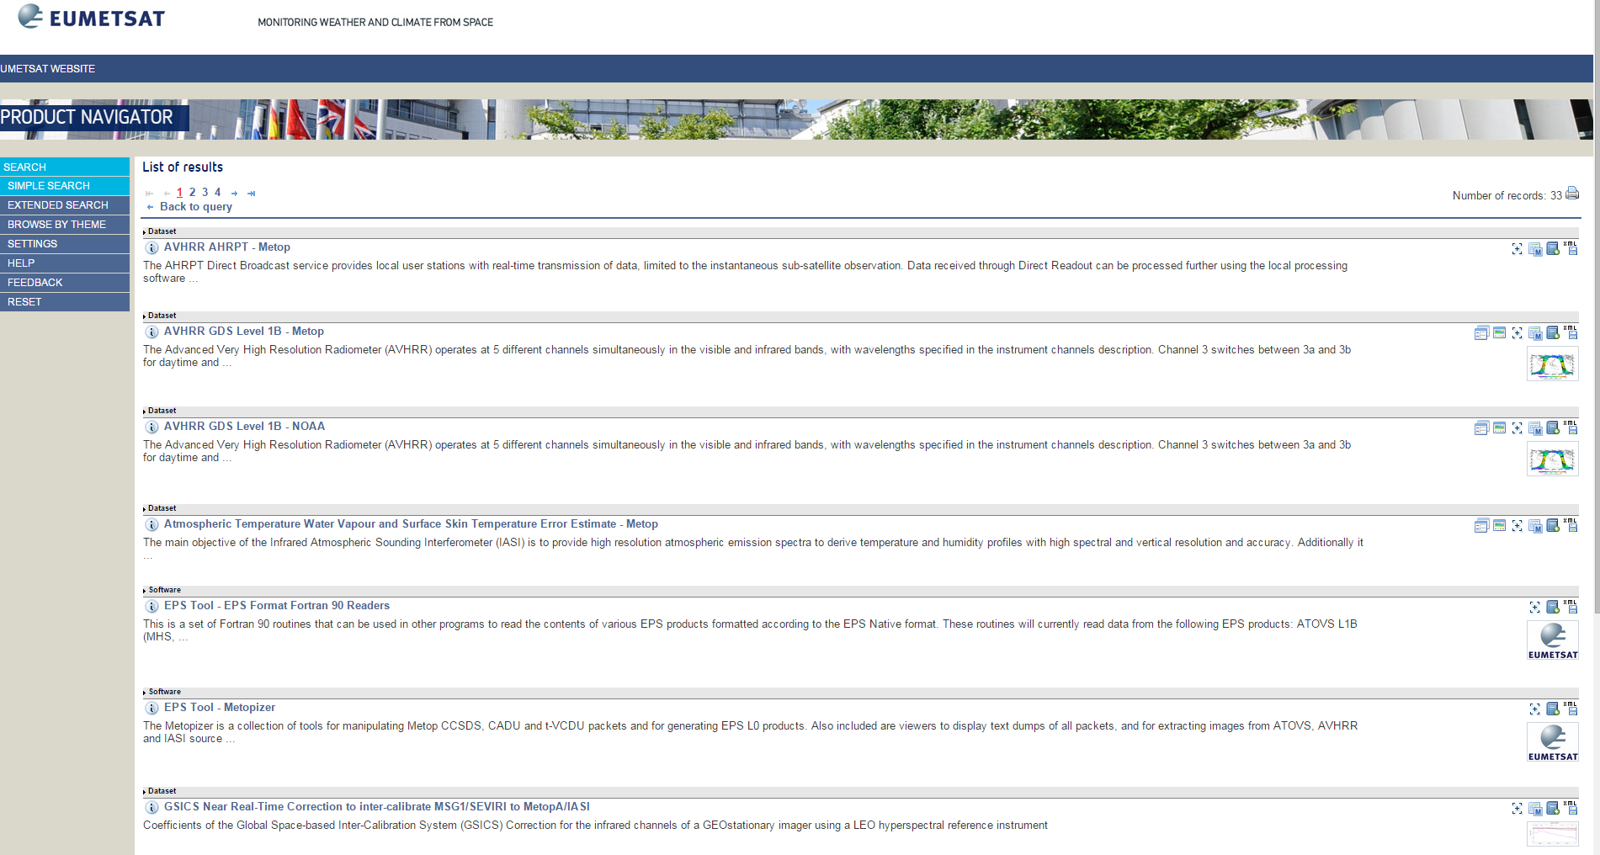

The user above searched for IASI products on the EUMETSAT DCPC WIS Portal and none-fully relevant results are returned in the first page. The user has to go to the second page to find complete IASI products. The search filter is also not shown here in the result list.

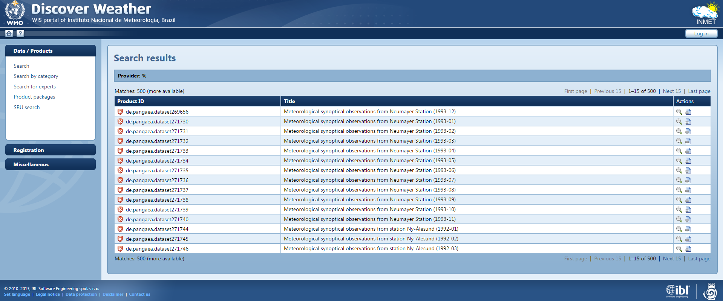

The user looks for “wind” products on the GISC Brasilia portal and a set of individual products from the same collection are returned in the first page and makes the search none relevant for the user.

**The satellite data user community recommends the WIS Portal providers to take into consideration to work on improving the quality of the search results returned by the WIS Portal. For instance, regrouping in collections metadata records from the GTS or individual climate records should allow minimizing their impact in the search results.**

## Presenting available products to first time users

First time users have reported to have difficulties understanding what are those portals used for and which products are made available from them. It is important for them to have the necessary information for describing that the WIS portals allow to access meteorological data products. They also would like to have a way to browse through the available list of products. This means that the products need to be categorised and ordered following a classification (themes). The WMO WIS metadata is already providing a classification with the CodeList Category and that classification could be enhanced and used by all WIS portals to provide a Browsing interface. Two WIS Portals: GISC Brasilia and GISC Beijing are providing a browsing interface. Another way could be to use that classification as filters in a built-in facetted search allowing users to restrict their searches.

It should also be noted that a Browsing interface is currently highly anticipated by users because of the inadequacy of the full-text search interface.

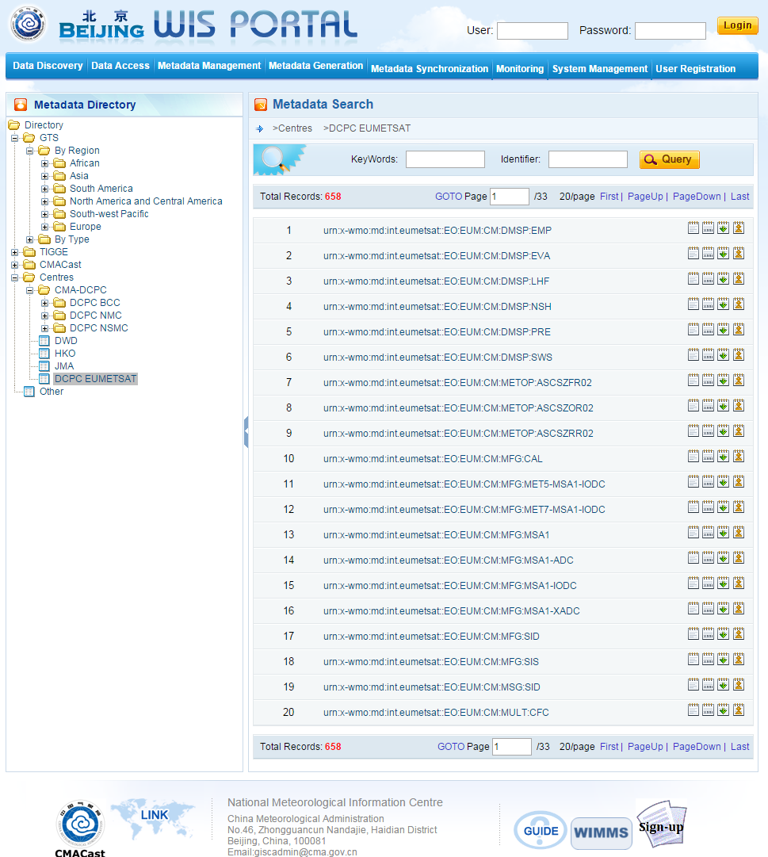

GISC Beijing provides a very helpful browsing by category interface.

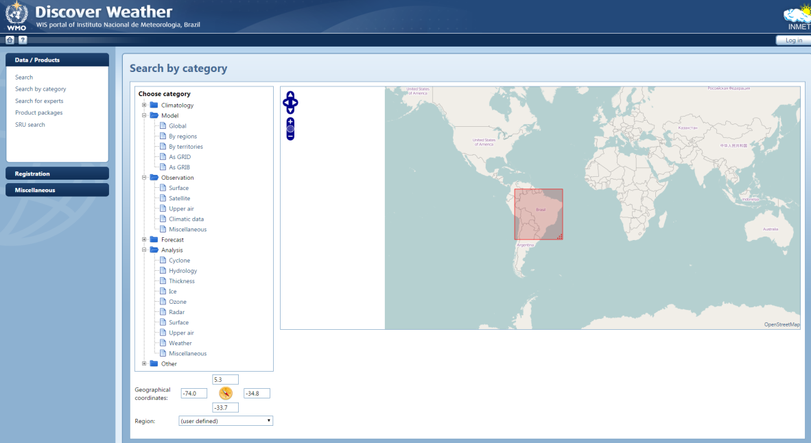

Another example of a browsing by category interface provided by GISC Brasilia.

***The WIS Portal providers should take into consideration the implementation of a browse by category search interface. Such feature would allow first time users to discover which types of data products are available from the WIS Portals.***

## Heterogeneity of the WIS portals

The WIS manual indicates that each GISC should have as a backup another GISC to redirect its users towards the backup GISC in case of issue. This technical decision makes the WIS highly available and redundant to best serve the users but the different WIS portals user interfaces are extremely different and diverse. It is very difficult, if not impossible for a user to feel at ease and being able to perform his daily work with a completely different user interface and finding the same results. There are currently six different types of user interfaces with different ways (as described above) to present the search parameters, the search results, the home page, the expert search pages, etc. Common navigation and usability traits should be defined and accepted by all WIS Portal providers similarly as technical interfaces have been defined during the establishment of the WIS. Those traits could be based on the universal conventions that have been defined over the years by the Web Search engine providers. Having navigability standardised in all WIS Portals will allow creating similar user experiences on all portals such that users will immediately understand all portal interfaces. Furthermore, additional features could still be implemented around those mandatory user interface traits but also different look and feel could still be provided, hence not preventing innovation and creativity over the years within the WIS community while having a solid user-interface bases for bring users to the WIS.

# Conclusion

The WIS has successfully managed to open the access to meteorological data products to potentially a broader community of users. It is however still difficult for a representative group of users such as the satellite data products users to use the diverse WIS portals. This users community understands the benefits of having a unique catalogue for meteorological products and feels that the currently implemented way to discover and access products through the WIS could be greatly improved with minor changes on the existing portals. It is recommended to the WIS implementers to take into consideration the following issues and proposals for improving WIS discovery portals:

***WIS Portals user interfaces are not centred on products.*** A solid and reliable technical platform has been established by the different organisations implementing the WIS discovery portals but the user interfaces and discovery services are currently focusing too much on those technical aspects and are not sufficiently conveying the information regarding meteorological products to the users. Users are only going to the WIS portals to get access to the meteorological products and focusing the search experience around the product content and information could greatly help increasing the user base.

***Complexity of the discovery interfaces.*** The WIS Portals provide technical specialised search interfaces that or have been related as complex by the satellite data users. Simplifying the WIS Portal user interfaces by following the convention established by the main web search engines such as for instance providing a unique search text box to search all metadata information, returning results each with a small description on the products would greatly help the users and correlating searches keywords with results should simplify the user interface and improve the user search experience.

**Provide better search results.** Satellite data users have indicated that the results returned are often not corresponding to the initial search keywords. In addition, the WIS catalogue have been populated by a majority of records referencing GTS bulletins and based on the bulletin notation and convention. As a result, often GTS bulletin records that can only be understood by specialised users populate the top hits. Furthermore lots of metadata records have been populated automatically with some information that does not provide a way to understand which product it is referencing. For all those reasons, it is recommended to improve the quality of the search results to attract and retain more satellite data users.

**Present products to first time users.** The WIS has been created to open the access of meteorological products previously reserved to GTS participants to a much broader audience. It would be beneficial for the WIS portals to offer a search interface allowing first time users to discover the list of products available on the WIS catalogue and guide them in their choice. Satellite data users have previously successfully on different Earth observation portals used a browse by products interface (faceted search) and would recommend WIS Portal implementers to take into consideration the integration of similar interfaces into WIS Portals.

**Create some homogeneity between the different WIS portals interfaces.** Users have reported large dissimilarities between the different WIS portals in the search experience. Users are meant to be redirected to a back up GISC in case of issues but it will be really difficult for users to work on the back-up GISC with those large interface differences. The Satellite data user community recommend taking into consideration the adoption of user interfaces and navigability convention allowing users to not feel disconcerted when being redirected to a backup WIS Portal.